**Lab Exercise on Inheritance & Abstract Class**

**Ayush Kumar – 21MCA1117**

1) VIT Chennai was established with UG courses like B.Tech and MS. The following details of UG students were stored: Name, Degree, Branch, GPA, Semester, Secondary School Name and % of marks in Secondary education. Later they started Master Degree Program for which some additional information of students' was stored: Basic Degree, College Name, and CGPA. After a couple of years, they offered PhD degree and for research students the following data was stored: Master Degree, College Name, CGPA, Area of Specialization, Supervisor's Name, in addition to the above information. Make sure that there must be the facility to store and display the data in every course.

Being a system programmer of VIT Chennai, you are asked to implement an application in Java with suitable inheritance.

import java.lang.*;

import java.util.Scanner;

class UG

{

public String name;

public String udegree;

public String branch;

public float gpa;

public int sem;

public String school;

public float smarks;

UG(String a,String b,String c,Float d ,int e,String f,float g)

{

name=a;

udegree=b;

branch=c;

gpa=d;

sem=e;

school=f;

smarks=g;

}

}

class PG extends UG

{

public String pdegree;

public String ucollege;

public float cgpa;

PG(String a,String b,String c,Float d ,int e,String f,float g,String h,String i,float j)

{

super(a,b,c,d,e,f,g);

pdegree=h;

ucollege=i;

cgpa=j;

}

}

class Phd extends PG

{

public String spc;

Phd(String a,String b,String c,Float d ,int e,String f,float g,String h,String i,float j,String k)

{

super(a,b,c,d,e,f,g,h,i,j);

spc=k;

}

void disp()

{

System.out.println("STUDENT DETAILS....");

System.out.println("Student Name..."+name);

System.out.println("School Name.."+school);

System.out.println("School In terms of percentage"+smarks);

System.out.println("********************");

System.out.println("UG Degree Details...");

System.out.println("UG Degree Namne..."+udegree);

System.out.println("UG  Degree Branch Name.. "+branch);

System.out.println("Degree Marks(GPA)..."+gpa);

System.out.println("Total Semister.."+sem);

System.out.println("********************");

System.out.println("PG Degree Details...");

System.out.println(" BASi PG Degree NAME.."+pdegree);

System.out.println("UG College Name.."+ucollege);

System.out.println("PG CGPA..."+cgpa);

System.out.println("PHD speciliazation.."+spc);

}

}

class javafilepractcie1

{

public static void main(String arg[])

{

Scanner obj = new Scanner(System.in);

System.out.println("Enter number of students");

int n=obj.nextInt();

Phd stud[]= new Phd[n];

for(int i=0;i<stud.length;i++)

{

stud[i] = new Phd("Rahul","BCA","Comp",9.5f,6,"SSDJ",85.2f,"MCA","SSR",9.28f,"Data sciecne");

stud[i].disp();

}

}

}

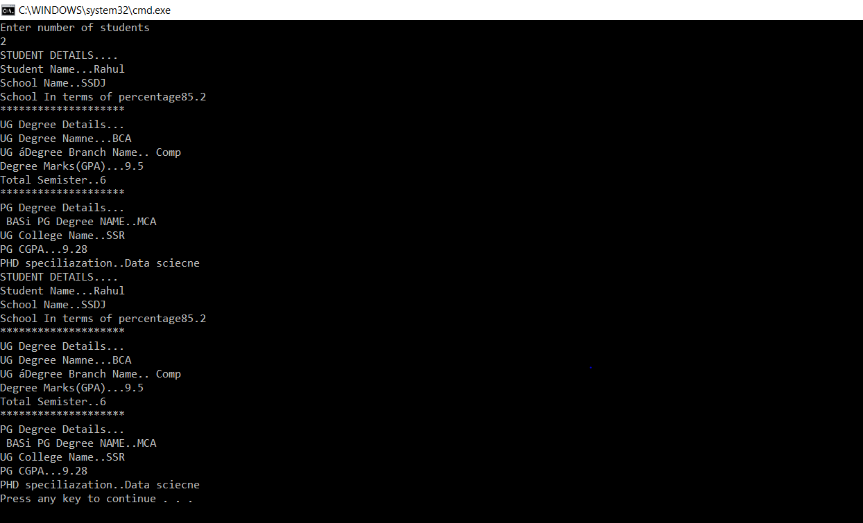

2) Consider a particle falling down freely under the gravity with initial velocity u. Its position at time t is given by the formula s = ut + ½ gt2 where g = 9.8 m/sec2. Write a program to calculate s for the values of u from 1 to 10 increments by 2 and values of t from 0 to 2 increment by 0.5. Use abstract class to implement the above scenario.

abstract class demo

{

final float g=9.8f;

abstract void cal();

}

class abc extends demo

{

int u;

float t;

double s;

abc()

{

u=1;

t=0.0f;

}

void cal()

{

for(int i=0;i<4;i++)

{

System.out.println("Value S for u= "+u+" And t= "+t);

s=((u*t)+(0.5*g*(t*t)));

System.out.println(s);

u=u+2;

t=t+0.5f;

}

}

}

class javafilepractcie1

{

public static void main(String []args)

{

abc obj=new abc();

obj.cal();

}

}

